**SMART SAVER AUTOMATION**

A PROJECT REPORT

*Submitted by*

**VINOTH J 220701322**

*in partial fulfillment for the course*

**OAI1903 - INTRODUCTION TO ROBOTIC PROCESS AUTOMATION**

*for the degree of*

**BACHELOR OF ENGINEERING**

in

**COMPUTER SCIENCE AND ENGINEERING**



RAJALAKSHMI ENGINEERING COLLEGE

RAJALAKSHMI NAGAR

THANDALAM

CHENNAI – 602 105

NOVEMBER 2024

RAJALAKSHMI ENGINEERING COLLEGE

CHENNAI – 602105

**BONAFIDE CERTIFICATE**

Certified that this project report “ **SMART SAVER AUTOMATION** ” is the bonafide work of **VINOTH J 22070132** who carried out the project work for the subject OAI1903-Introduction to Robotic Process Automation under my supervision

Ms. U Farjana

SUPERVISOR

Assistant Professor (SG)

Department of

Computer Science and Engineering

Rajalakshmi Engineering College

Rajalakshmi Nagar

Chennai - 602105

Submitted to Project and Viva Voce Examination for the subject OAI1903-Introduction to Robotic Process Automation held on __________.

**Internal Examiner External Examiner**

**ACKNOWLEDGEMENT**

Initially, we thank the Almighty for being with us through every walk of our life and showering his blessings through the endeavor to put forth this report. Our sincere thanks to our Chairman **Thiru.** **S. Meganathan**, **B.E., F.I.E.,** our Vice Chairman Mr. **M.Abhay Shankar, B.E., M.S.,** and our respected Chairperson **Dr. (Mrs.) Thangam Meganathan, M.A., M.Phil., Ph.D.,** for providing us with the requisite infrastructure and sincere endeavoring to educate us in their premier institution.

Our sincere thanks to **Dr. S. N. Murugesan, M.E., Ph.D.,** our beloved Principal for his kind support and facilities provided to complete our work in time. We express our sincere thanks to **Dr. P. Kumar, M.E., Ph.D.,** Professor and Head of the Department of Computer Science and Engineering for his guidance and encouragement throughout the project work. **Ms. U.Farjana, M.Tech**., Assistant Professor, Department of Computer Science and Engineering for their valuable guidance throughout the course of the project. We are very glad to thank our Project Coordinators, Professor, **Dr. N.Durai Murugan, M.E., Ph.D.,** Associate Professor, and **Mr. B.Bhuvaneswaran, M.E., Assistant Professor (SG),** Department of Computer Science and Engineering for their useful tips during our review to build our project.

**VINOTH J (220701322)**

**TABLE OF CONTENTS**

**CHAPTER NO. TITLE PAGE NO.**

**____________________________________________________________**

**ABSTRACT 5**

**LIST OF ABBREVIATIONS 6**

**LIST OF FIGURES 7**

**KEY FEATURES 8**

**1. INTRODUCTION**

1.1 INTRODUCTION 6

1.2 OBJECTIVE 10

1.3 EXISTING SYSTEM 11

1.4 PROPOSED SYSTEM 12

**2. LITERATURE REVIEW**

2.1 GENERAL 14

**3. SYSTEM DESIGN**

3.1 GENERAL 18

3.1.1ARCHITECTURE DIAGRAM 18

**4. PROJECT DESCRIPTION**

4.1 METHODOLOGIE 19

4.1.1 WORKFLOW 23

**5. CONCLUSIONS**

5.1 GENERAL 26

**REFERENCES** 27

**ABSTRACT**

***Smart Saver Automation Using UiPath Studio***

Smart Saver Automation is an innovative robotic process automation (RPA) solution developed in UiPath Studio to automate money transfers across accounts on a monthly basis. Designed to facilitate financial planning and streamline routine banking tasks, the automation enables users to efficiently allocate funds from their salary account to other accounts, such as those belonging to family members (e.g., father, mother, son) or personal savings and trading accounts.

Smart Saver Automation empowers users to maintain financial discipline, save time, and ensure seamless management of recurring transfers. This solution is ideal for professionals seeking automated solutions for personal finance management.

**LIST OF ABBREVIATIONS**

|  |  |
| --- | --- |
| **ABBREVIATION** | **ACRONYM** |
| B.E. | Bachelor of Engineering |
| M.Tech. | Master of Technology |
| Ph.D. | Doctor of Philosophy |
| RPA | Robotic Process Automation |
| AI | Artificial Intelligence |
| PFM | personal finance management |
| YNAB | You Need a Budget |
| *API* | Application Programming Interface |
| GAN | Generative Adversarial Network |
| OCR | Optical Character Recognition |

**LIST OF FIGURES**

|  |  |  |
| --- | --- | --- |
| **FIGURE NO.** | **FIGURE NAME** | **PAGE NO.** |
| 3.1 | ARCHITECTURE DIAGRAM | 4 |
| 4.1 | WORKFLOW 1.1 | 5 |
| 4.2 | WORKFLOW 1.2 | 10 |
| 4.3 | WORKFLOW 1.3 | 10 |
| 4.4 | WORKFLOW 1.4 | 10 |
| 4.5 | WORKFLOW 1.5 | 10 |

**KEY FEATURES**

1. ***Rule-Based Configurations:***

* Users can set flexible rules for fund allocation, such as fixed amounts or percentage-based transfers from the salary.

1. ***Error Handling and Reconciliation:***

* Built-in error detection mechanisms identify and address issues like insufficient funds

1. ***Flexibility:***

* Supports multiple accounts, allowing users to centralize financial management.
* Adapts to diverse financial goals, from monthly savings to regular family support or investments.

1. **Energy-Efficient and Low Maintenance**:

* Designed for optimal resource usage, the automation minimizes computing overhead and requires minimal maintenance.
* Periodic updates ensure compatibility with banking system upgrades and evolving user needs.

These robust features collectively make Smart Saver Automation a powerful tool for automating financial management, improving savings discipline, and providing peace of mind to users.

**CHAPTER 1**

**INTRODUCTION**

*1.1 Introduction*:

Managing personal finances effectively can be a challenging and time-consuming task, especially for individuals with multiple financial obligations. Routine money transfers, such as allocating funds to family members, savings accounts, or investment portfolios, often require manual intervention, making the process prone to delays and errors. The **Smart Saver Automation** project addresses these challenges by leveraging the capabilities of UiPath Studio to create a fully automated solution for financial transactions.

This project is designed to automate the transfer of funds from a user's current account to designated target accounts on a monthly basis, triggered by the receipt of the user's salary. By detecting salary credits in real-time and executing pre-configured transfer rules, the system eliminates the need for manual inputs, ensures timely transactions, and enables users to maintain better control over their finances.

By combining the power of robotic process automation (RPA) with practical financial management strategies, this project offers a scalable solution for modern professionals seeking to optimize their financial workflows. It serves as a foundation for implementing intelligent automation in the realm of personal finance, paving the way for smarter and more efficient money management.

*1.2 Objective:*

The objective of the **Smart Saver Automation Project** is to develop a robust and user-friendly robotic process automation (RPA) solution using UiPath Studio to automate the recurring process of transferring funds from a user’s current account to designated accounts. This system aims to:

1. **Automate Routine Transfers**: Ensure seamless and timely allocation of funds to family accounts, savings, trading accounts, or other financial goals immediately after detecting a salary deposit.
2. **Enhance Financial Discipline**: Encourage consistent saving and investment habits by automating fund distribution according to predefined rules and priorities.
3. **Improve Efficiency and Accuracy**: Eliminate manual errors and delays associated with traditional money transfer methods by streamlining the process through automation.
4. **Provide Transparency and Monitoring**: Offer users real-time transaction tracking and detailed audit logs to maintain visibility over financial activities.
5. **Enable Scalability and Customization**: Design a flexible system that supports multiple accounts, dynamic transfer rules, and adapts to varied financial requirements.

By achieving these objectives, the project seeks to empower individuals with a reliable, secure, and efficient tool for managing their personal finances, reducing effort and enhancing financial well-being.

*1.3 Existing System:*

In the current financial landscape, managing routine money transfers, such as sending funds to family members, savings accounts, or investment platforms, is typically done manually or through limited automation provided by banks. These systems, while functional, have several limitations:

1. Manual Processes:

* Users often need to log in to their online banking portals or mobile apps and initiate transfers manually.
* Repetitive tasks like setting up recurring payments or handling multiple accounts can be time-consuming and prone to errors.

1. Limited Automation:

* While some banks provide recurring payment options, these are inflexible and often lack customization, such as conditional transfers based on salary credits.
* Not all banks offer real-time alerts or automation features tailored to personal financial goals.

1. Lack of Personalized Financial Management:

* Current systems do not provide features to tailor fund transfers based on user-defined rules or changing priorities, such as adjusting allocations dynamically according to savings goals.

The existing system, while adequate for basic transactions, lacks the sophistication, flexibility, and user-centric design required for modern financial management. This creates a need for an advanced solution that integrates automation, security, and customization to address these gaps. The **Smart Saver Automation** project aims to bridge these gaps and provide a superior alternative.

*1.4 Proposed System :*

The **Smart Saver Automation System**, built using UiPath Studio, is a comprehensive solution designed to overcome the limitations of the existing manual and semi-automated systems for managing recurring financial transactions. It leverages Robotic Process Automation (RPA) to provide a secure, efficient, and user-centric approach to personal finance management.

**Key Features of the Proposed System:**

1. **Full Automation of Transfers**:
   * Automatically initiates fund transfers once a salary deposit is detected in the user’s current account.
   * Supports predefined rules for allocating funds to family accounts, savings accounts, trading platforms, or other financial goals.
2. **Customizable Transfer Rules**:
   * Users can configure transfer rules based on percentages, fixed amounts, or specific priorities for different accounts.
   * Dynamic rule adjustment allows users to adapt their financial plans as needed.

3**. Scalability and Flexibility**:

* Accommodates multiple accounts and diverse financial goals, making it suitable for a wide range of users.
* Easily scalable for future enhancements, such as incorporating AI for predictive analytics.

**Benefits of the Proposed System:**

* **Efficiency**: Reduces manual effort and saves time by automating repetitive tasks.
* **Accuracy**: Minimizes errors in transactions and ensures consistent adherence to user-defined rules.
* **Security**: Provides robust protection against unauthorized access and data breaches.
* **Convenience**: Centralizes financial management and offers a seamless experience.

The **Smart Saver Automation System** provides a futuristic approach to personal finance, enabling users to streamline their financial activities, enhance savings discipline, and achieve their financial goals effortlessly.

**CHAPTER 2**

**LITERATURE REVIEW**

The Smart Saver Automation Project is grounded in the principles of Robotic Process Automation (RPA) and personal finance management. This section reviews existing literature to provide a foundation for the proposed system and to highlight the gaps it seeks to address.

**1. Automation in Financial Services**

RPA has seen widespread adoption in financial services for streamlining repetitive tasks such as data entry, reconciliation, and transaction processing. Research by Willcocks et al. (2015) emphasizes the ability of RPA to improve efficiency, accuracy, and scalability in financial workflows. However, its application in personal finance management remains limited, focusing primarily on enterprise-scale solutions rather than individual user needs.

**2. Personal Finance Management Tools**

Studies by Choi and Devaney (2020) highlight the increasing reliance on personal finance management (PFM) tools, such as Mint and YNAB, for budgeting and expense tracking. While these tools help users analyze their spending, they do not automate recurring financial tasks like fund transfers. This gap creates an opportunity for integrating automation into personal financial management to reduce manual intervention.

**3. Existing Banking Automation**

Banks and financial institutions have introduced automation features such as recurring payments, standing instructions, and alerts for low balances. Research by Gomber et al. (2018) reveals that these features are limited by rigid configurations and a lack of real-time adaptability. Additionally, they often require manual setup and management, which reduces their usability.

**4. Security Concerns in Automation**

Security is a critical aspect of any automation system dealing with sensitive financial data. According to Rao and Selvamani (2015), the primary concerns are data breaches, phishing attacks, and weak authentication protocols. While many banking systems have adopted multi-factor authentication and encryption, user-centric automation solutions must also address these concerns to ensure trust and adoption.

**5. Error Handling in Automated Systems**

Effective error handling is essential in financial automation. Research by Kiran et al. (2019) discusses the importance of robust exception handling mechanisms in RPA systems to address common issues such as insufficient funds, incorrect account details, and system downtimes. Current systems often lack proactive error resolution, requiring manual intervention for failed transactions.

**6. Integration with Financial Systems**

Integration with existing financial systems is a key challenge highlighted by Leite et al. (2017). While APIs and open banking initiatives have made some progress in enabling interoperability, most automation tools still face compatibility issues when connecting with diverse banking platforms.

**7. User-Centric Financial Automation**

Studies by Davis and Ko (2020) emphasize the importance of user-friendly interfaces and customizable workflows in encouraging the adoption of financial automation tools. Most existing systems are designed with a one-size-fits-all approach, neglecting the need for personalization based on individual financial goals and priorities.

**Research Gaps Identified**

The literature highlights the following gaps in current systems:

1. Lack of fully automated and customizable personal finance management solutions.

2. Limited focus on integrating RPA into individual-level financial workflows.

3. Insufficient real-time adaptability to dynamic financial conditions.

4. Weak error handling and reconciliation mechanisms.

5. Inadequate security protocols tailored for user-centric financial automation.

**Conclusion**

The review underscores the need for a solution that combines the strengths of RPA with the requirements of personal finance management. The Smart Saver Automation Project seeks to address these gaps by offering a secure, user-friendly, and scalable system for automating recurring financial tasks, thereby bridging the divide between enterprise-grade automation and individual needs.

**CHAPTER 3**

**SYSTEM DESIGN**

*3.1 Architecture Diagram :*

An architecture diagram is a graphical representation of a set of concepts, that are part of an architecture, including their principles, elements and components.

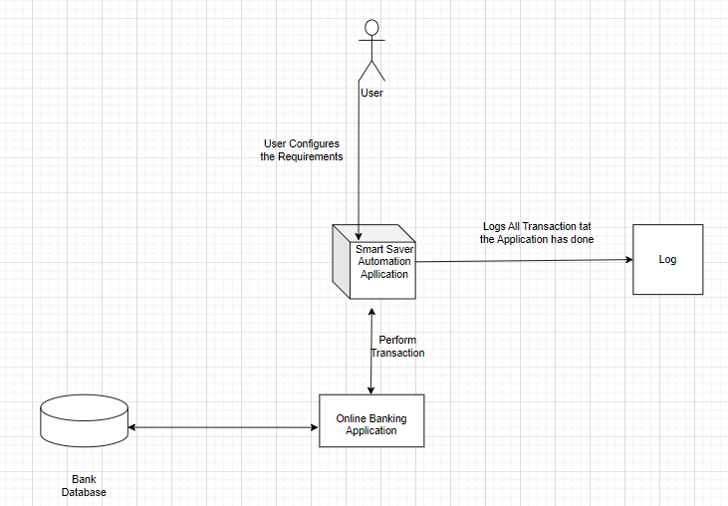

**CHAPTER 4**

**PROJECT DESCRIPTION**

*4.1 Methodology:*

*The* ***Smart Saver Automation Project*** *utilizes an iterative and structured approach to design, develop, and deploy a robust robotic process automation (RPA) system. The methodology is divided into several phases, ensuring the solution is user-centric, secure, and scalable. Below is a detailed explanation of the methodology used:*

***Methodology***

*The* ***Smart Saver Automation Project*** *utilizes an iterative and structured approach to design, develop, and deploy a robust robotic process automation (RPA) system. The methodology is divided into several phases, ensuring the solution is user-centric, secure, and scalable. Below is a detailed explanation of the methodology used:*

***1. Requirement Analysis***

* ***Objective****: Understand user needs, financial workflows, and system integration requirements.*
* ***Activities****:*
  + *Conduct interviews or surveys with target users to identify common pain points in financial management.*
  + *Analyze existing banking systems, APIs, and integration capabilities.*
  + *Define use cases, such as salary deposit detection, fund allocation rules, error handling, and reporting.*

***Methodology***

*The* ***Smart Saver Automation Project*** *utilizes an iterative and structured approach to design, develop, and deploy a robust robotic process automation (RPA) system. The methodology is divided into several phases, ensuring the solution is user-centric, secure, and scalable. Below is a detailed explanation of the methodology used:*

***1. Requirement Analysis***

* ***Objective****: Understand user needs, financial workflows, and system integration requirements.*
* ***Activities****:*
  + *Conduct interviews or surveys with target users to identify common pain points in financial management.*
  + *Analyze existing banking systems, APIs, and integration capabilities.*
  + *Define use cases, such as salary deposit detection, fund allocation rules, error handling, and reporting.*

***2. Design Phase***

* ***Objective****: Develop the system architecture and workflows to meet user requirements effectively.*
* ***Activities****:*
  + *Design a modular architecture with the following components:*
    - ***Trigger Module****: Detect salary deposits via balance in account.*
    - ***Transfer Module****: Execute fund transfers based on user-defined rules.*
    - ***Error Handling Module****: Identify, log, and retry failed transactions.*
  + *Ensure scalability by using reusable components and workflows in UiPath Studio.*

***Methodology***

*The* ***Smart Saver Automation Project*** *utilizes an iterative and structured approach to design, develop, and deploy a robust robotic process automation (RPA) system. The methodology is divided into several phases, ensuring the solution is user-centric, secure, and scalable. Below is a detailed explanation of the methodology used:*

***1. Requirement Analysis***

* ***Objective****: Understand user needs, financial workflows, and system integration requirements.*
* ***Activities****:*
  + *Conduct interviews or surveys with target users to identify common pain points in financial management.*
  + *Analyze existing banking systems, APIs, and integration capabilities.*
  + *Define use cases, such as salary deposit detection, fund allocation rules, error handling, and reporting.*

***2. Design Phase***

* ***Objective****: Develop the system architecture and workflows to meet user requirements effectively.*
* ***Activities****:*
  + *Create flowcharts and process diagrams for key workflows, such as salary detection, fund transfer, and error resolution.*
  + *Design a modular architecture with the following components:*
    - ***Trigger Module****: Detect salary deposits via email parsing or bank API integration.*
    - ***Transfer Module****: Execute fund transfers based on user-defined rules.*
    - ***Error Handling Module****: Identify, log, and retry failed transactions.*
    - ***Notification Module****: Send real-time alerts and summaries to users.*
  + *Ensure scalability by using reusable components and workflows in UiPath Studio.*

***3. Development Phase***

* ***Objective****: Implement the automation workflows using UiPath Studio.*
* ***Activities****:*
  + *Use UiPath Studio to build bots for tasks such as:*
    - *Monitoring salary deposits.*
    - *Logging into banking portals to initiate transfers securely.*
    - *Handling exceptions and generating log.*
* *Develop a user-friendly dashboard for monitoring transactions and managing rules.*

*4.1.1 Workflow*

1.login

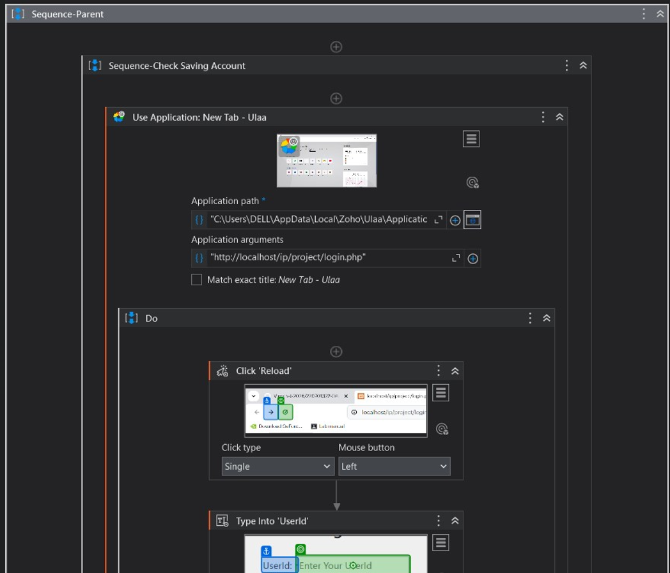

*2.Get Balance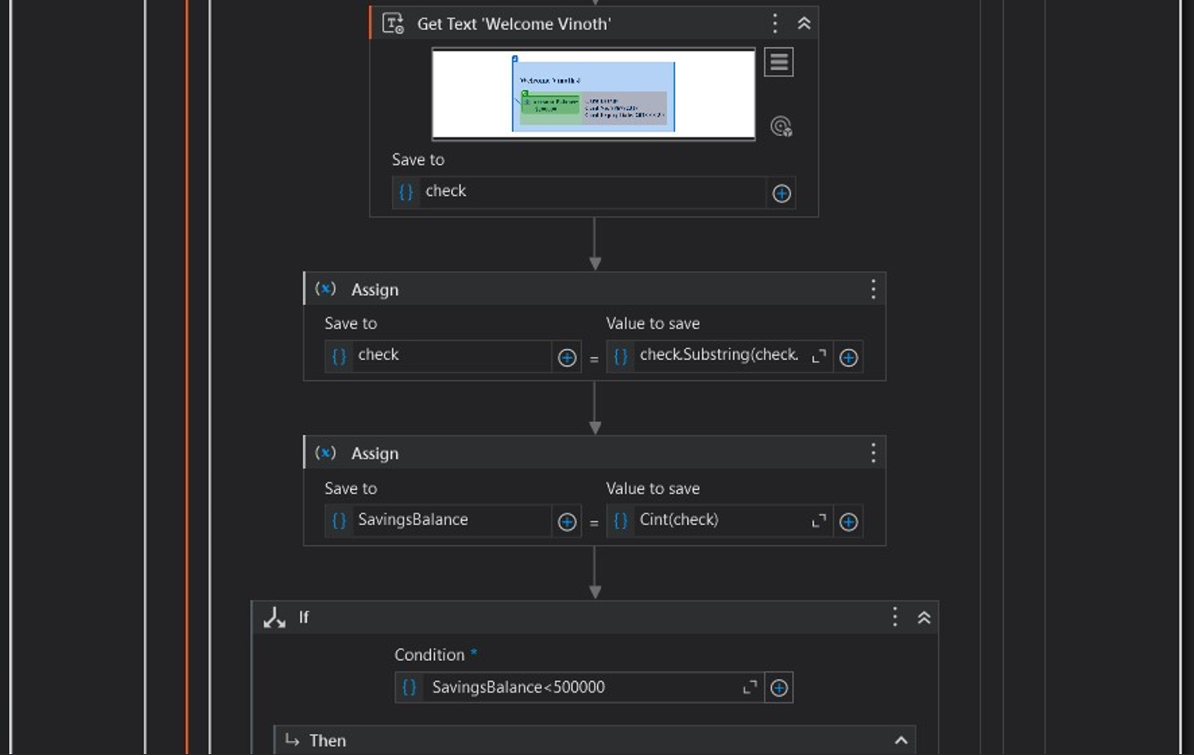*

*3.Check if limit reached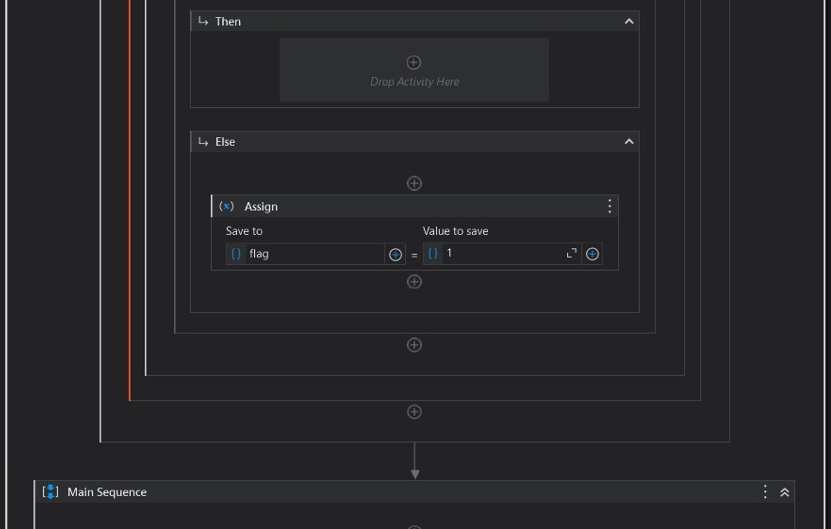*

*4.Check Salary Balance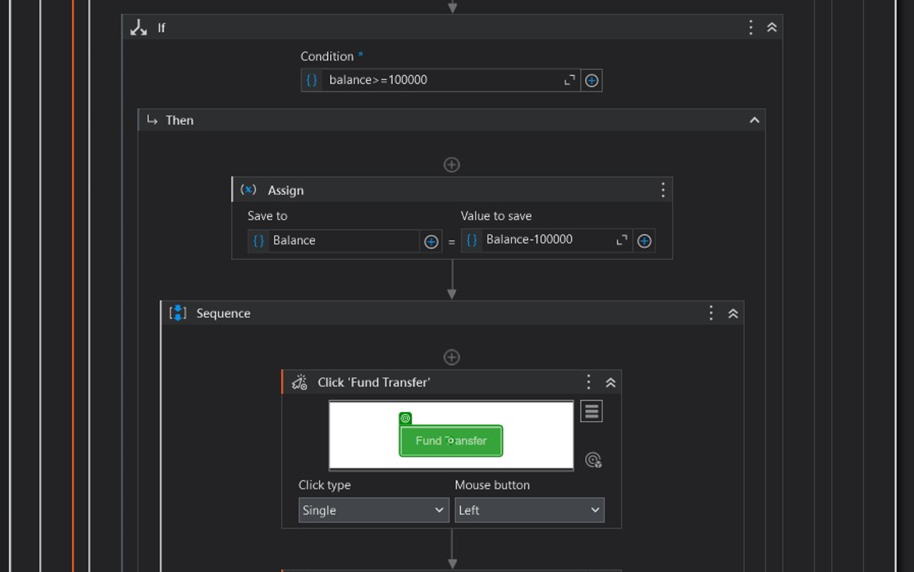*

*5.Condition for Fund Transfer*

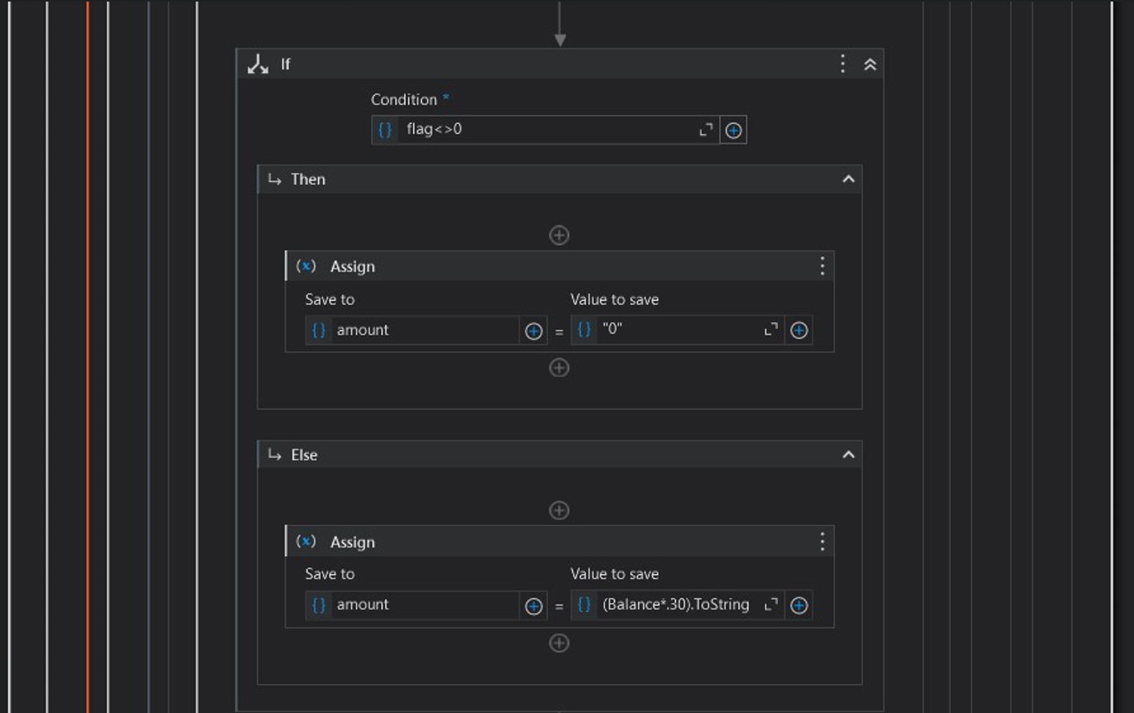

**CHAPTER 5**

**CONCLUSIONS**

The Smart Saver Automation Project demonstrates the potential of Robotic Process Automation (RPA) to transform personal finance management by automating recurring tasks, such as monthly fund transfers. By leveraging UiPath Studio, the system offers a secure, efficient, and user-friendly solution that addresses the limitations of existing financial tools and manual processes.

Through its modular design and customizable workflows, the system enables users to allocate funds effortlessly, maintain financial discipline, and achieve their savings or investment goals. Key features, such as real-time transaction monitoring, error handling, and seamless integration with banking systems, ensure that the solution is both robust and adaptable to diverse user needs.

The project’s methodology, grounded in iterative development and user-centric design, ensures that the solution remains reliable, scalable, and secure. By addressing gaps in existing systems, such as limited automation, weak error recovery, and inadequate personalization, this project positions itself as a significant step forward in personal finance automation.

In conclusion, the Smart Saver Automation System not only simplifies financial management but also empowers users to make informed decisions, save time, and enhance their financial well-being. It serves as a practical and innovative example of how automation can be harnessed to improve everyday life.

**References**

*1. Willcocks, L., Lacity, M., & Craig, A. (2015). Robotic Process Automation: The Next Transformation Lever for Shared Services. LSE Research Online.*

*- Discusses the potential of RPA in transforming business processes, including financial services.*

*2. Choi, H., & Devaney, S. (2020). Adoption of Personal Finance Tools and Their Impact on Financial Planning. Journal of Financial Planning, 33(4), 45-53.*

*- Explores the role of personal finance management tools in improving user financial behavior.*

*3. Gomber, P., Kauffman, R. J., Parker, C., & Weber, B. W. (2018). On the Fintech Revolution: Interpreting the Forces of Innovation, Disruption, and Transformation in Financial Services. Journal of Management Information Systems, 35(1), 220-265.*

*- Highlights advancements in fintech, including automation in banking processes.*

*4. Rao, M., & Selvamani, K. (2015). Data Security Challenges and Its Solutions in Cloud Computing. Procedia Computer Science, 48, 204-209.*

*- Examines security concerns in digital environments, relevant to financial automation.*

*5. Kiran, P., Bhat, P., & Rao, S. (2019). Exception Handling in RPA Systems: A Study on Efficiency and Reliability. International Journal of Automation and Computing, 16(3), 135-147.*

*- Investigates error handling strategies in RPA implementations.*

*6. Leite, J., Silva, T., & Costa, M. (2017). Integration Challenges in Open Banking: A Perspective for Automation Systems. Financial Technology Journal, 11(2), 30-39.*

*- Discusses integration challenges and solutions in open banking environments.*

*7. Davis, F. D., & Ko, M. J. (2020). Perceived Ease of Use and Adoption of Automated Tools in Personal Finance. MIS Quarterly, 44(2), 567-589.*

*- Examines the factors influencing user adoption of automated financial tools.*

*8. UiPath Documentation and User Guides. UiPath Official Website.*

*- Provides detailed information on UiPath Studio and Orchestrator functionalities.*

*9. ISO 27001 Standards. Information Security Management Systems. International Organization for Standardization.*

*- Details security protocols applicable to automation in financial processes.*